Shattered Protocols Test Report 2.0, Unit test focus
Report covers the testing scope, test schedule, product features and quality, a list of all flags remaining open with a RISK assessment, and lessons learned.
Test Report
- Project Title: Shattered Protocols
- Test Report Scope: Report on the increments 1, 2, 3 and 4 testing associated with release 1 and 2 testing, and system testing.
- Test team: Seth Welton
- Test Schedule:
  - Iteration 1.0 finished on 4 Nov 2024
  - Iteration 2.0 will be on finished on 14 Nov 2024
- Test Description: describe each test, what was tested and the test outcome:
a. To make sure each room displays correct script lines on entry: Intro to room and Intro to Puzzle.
- Test each room entry on if Room Inro pops on screen:
-R0 = Front Desks: Success
-R1 = Meeting Room: Success
-R2 = Development Lab: Success
-R3 = Heart of Operations: Success
-R4 = Testing Lab: Success
-R5 = Break Room: Success
-R6 = Server Room: Success

- Test each room entry on if Puzzle Inro pops on screen:
-R0 = Front Desks: Success
-R1 = Meeting Room: Success
-R2 = Development Lab: Success
-R3 = Heart of Operations: Success
-R4 = Testing Lab: Success
-R5 = Break Room: N/A
-R6 = Server Room: Success
b. To make sure each puzzle is in correct room (They were moved around since I1)
- Check if puzzle is in correct room:
-R0 = Front Desks: Success
-R1 = Meeting Room: Success
-R2 = Development Lab: Success
-R3 = Heart of Operations: Success
-R4 = Testing Lab: Success
-R5 = Break Room: N/A
-R6 = Server Room: Success
c. Solve the puzzles (with no expectation other than a “good job you solved it”).
- Try each room’s puzzle with correct input that will solve the puzzle:
-R0 = Front Desks: Success
-R1 = Meeting Room: answer: “role:\s*admin” does not work
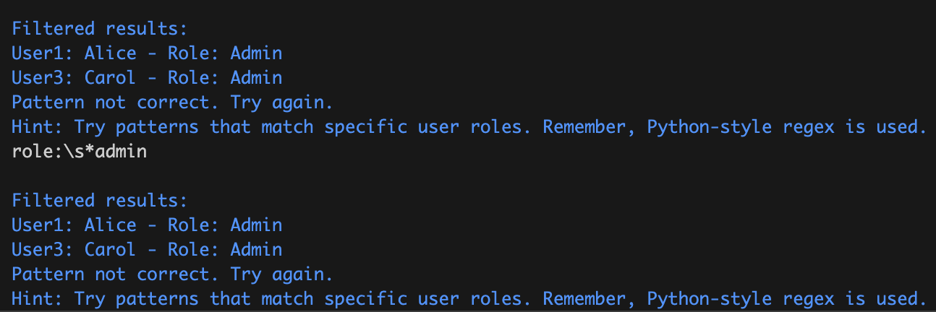
-R2 = Development Lab: Doesn’t work, but a new puzzle is being developed for this one anyway in the next iteration.
-R3 = Heart of Operations: Success
-R4 = Testing Lab: Success
-R5 = Break Room: N/A
-R6 = Server Room: Success

- Try each room’s puzzle with incorrect input to fail the puzzle 10 times each.
-R0 = Front Desks: Success
-R1 = Meeting Room: Does not handle * as first character in input.
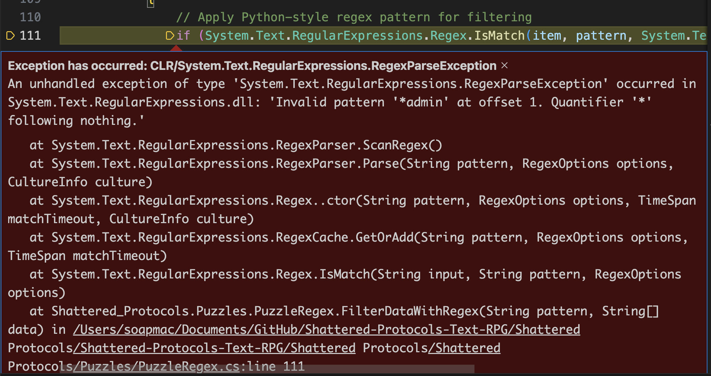
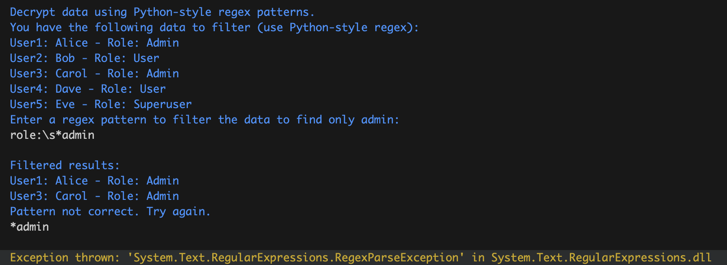
-R2 = Development Lab: Doesn’t work, but a new puzzle is being developed for this one anyway in the next iteration.
-R3 = Heart of Operations: Incorrect tries 3+ always give same hint over and over again.
-R4 = Testing Lab: Incorrect tries 3+ always give same hint over and over again.
-R5 = Break Room: N/A
-R6 = Server Room: Success
d. To make sure each puzzle displays correct Puzzle Outro.
- Test each puzzle completion on if Puzzle Outro pops on screen.
-R0 = Front Desks: Success
-R1 = Meeting Room: Unable to test due to no way to solve puzzle
-R2 = Development Lab: Unable to test due to no way to solve puzzle
-R3 = Heart of Operations: N/A, End Game Not Implemented Yet
-R4 = Testing Lab: Success
-R5 = Break Room: N/A
-R6 = Server Room: Success
e. To make sure that the unsolved puzzle resets its try count when the user leaves the room and comes back.
- Test if the puzzle resets on reentry. Test each room by giving incorrect answers to a point of a hint, leaving the room, reentering the room and then giving incorrect answers to same point expecting same hint.
-R0 = Front Desks: Does not reset
-R1 = Meeting Room: Does not reset
-R2 = Development Lab: Does not reset
-R3 = Heart of Operations: Does not reset
-R4 = Testing Lab: Does not reset
-R5 = Break Room: N/A
-R6 = Server Room: Does not reset

- Final product features and quality: describe the final product and any flaws

-The rooms lock when a puzzle is solved instead of having the puzzles unlock the doors upon completion. This is something that will get fixed in the next iteration when the locks are properly implemented. This bug is just a remnant of an early version of the locking system and it managed to be complicated enough to need to shift the mechanic to iteration 3.

-When trying to solve a puzzle, if the player leaves the room and comes back to try to solve it again, the attemptCount does not reset. This could result in some hints getting buried and the user would be forced to scroll up on the history to try and find a previous hint instead of the puzzle just starting fresh.

- The puzzles have been moved around to match the theme of the rooms. The rooms have intros, and the puzzles have intros and outros. These thematic changes make the game more fun and immersive as the user can kind of imagine where he/she is and what he/she is doing as the puzzles are getting solved.

-The regex puzzle has replaced the reverse string puzzle. This was in pursuit of having a more engaging computer science puzzle. Being able to make a regular expression to filter through results is a good skill to have as a computer scientist. The reverse string puzzle could be remodeled and reused in a future iteration, but at the moment we have just removed it.

-The current state of the game is in progress. We have more world building in place from intros and outros. The room traversal mostly works as there are no more infinite loops of the same doors stemming from the Testing Room (R4). The puzzles are coming together as they are fun and most of them work.

- Test Flags and Risk Management: List all open flaws/flags remaining and provide a RISK assessment for each
-Flaw: Each time a puzzle is completed, the door locks and there is no way to unlock the door (LOL). Level of severity: Very High.
Risk assessment: This will impede the user experience as solving the puzzles will soft lock the game (ironically). This bug will cause frustration from the user as each time a puzzle is completed, he/she gets stuck. This bug will get fixed in the next iteration though as it focuses on correct lock implementation.
-Flaw: Each room does not have a the “try counter” reset. Level of severity: light.
Risk assessment: The intention was to make the counter reset for a better user experience, but implementation needs a little bit of work. The user could experience mild frustration as the hints don’t reset for the puzzles, but it does not break the game in any way, so it is not too bad.
- Lessons Learned from testing

-These test reports are surprising amount of work. More and more things popped into my head that needed to be tested as the testing was going along. Then, those new tests needed to be implemented into the Test Plan and the Test Report. This includes making sure all the formatting doesn’t get messed up when adding stuff.

-Testing for more incorrect inputs than just “1”, “2”, “3”, etc... is necessary on certain puzzles. For example, I was not expecting that “*” at the beginning of the regex puzzle would break it. So, for any puzzle that does not just directly compare strings as output, more types of test inputs need to be tested.

